Tab 2
ITA0601 MACHINE LEARNING
EXP 8
Write a program to implement Linear Regression (LR) algorithm in python

To implement Linear Regression for prediction.
Procedure
1. Import the Linear Regression model.
2. Create the dataset and target values.
3. Train the model using the training data.
4. Predict a new value.
5. Display the predicted result.

Dataset 1: House Price Prediction
Target Variable: Price (₹ Lakhs)

House Size (sq.ft) | Bedrooms | House Age (Years) | Price (₹ Lakhs)
800 | 2 | 10 | 35
1000 | 2 | 8 | 45
1200 | 3 | 6 | 55
1400 | 3 | 5 | 65
1600 | 4 | 4 | 75
1800 | 4 | 3 | 85
2000 | 5 | 2 | 95
2200 | 5 | 1 | 105
2400 | 6 | 1 | 115
2600 | 6 | 0 | 125

PROGRAM
# Linear Regression - House Price Prediction

data = [
[800,2,10,35],
[1000,2,8,45],
[1200,3,6,55],
[1400,3,5,65],
[1600,4,4,75],
[1800,4,3,85],
[2000,5,2,95],
[2200,5,1,105],
[2400,6,1,115],
[2600,6,0,125]
]

X = [r[:3] for r in data]
y = [r[3] for r in data]

# Mean and scale
mean = [sum(r[j] for r in X)/len(X) for j in range(3)]
scale = [max(r[j] for r in X)-min(r[j] for r in X) for j in range(3)]

# Normalize X
A = [[1] + [(r[j]-mean[j])/scale[j] for j in range(3)] for r in X]

def transpose(A):
return list(map(list, zip(*A)))

def multiply(A,B):
return [[sum(A[i][k]*B[k][j] for k in range(len(B)))
for j in range(len(B[0]))] for i in range(len(A))]

def inverse(A):
n = len(A)
I = [[float(i==j) for j in range(n)] for i in range(n)]

for i in range(n):
p = A[i][i]

for j in range(n):
A[i][j] /= p
I[i][j] /= p

for k in range(n):
if k != i:
p = A[k][i]

for j in range(n):
A[k][j] -= p*A[i][j]
I[k][j] -= p*I[i][j]

return I

# Train Linear Regression
At = transpose(A)
w = multiply(
multiply(inverse(multiply(At,A)),At),
[[v] for v in y]
)

# New sample
new = [1700,4,3]
new = [(new[j]-mean[j])/scale[j] for j in range(3)]

prediction = w[0][0] + sum(w[j+1][0]*new[j] for j in range(3))

print("Predicted House Price:", round(prediction,2), "Lakhs")
OUTPUT
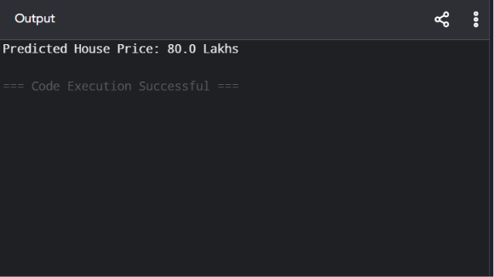

Dataset 2: Student Marks Prediction
Target Variable: Final Marks

Study Hours | Attendance (%) | Assignment Score | Final Marks
2 | 70 | 60 | 55
3 | 75 | 65 | 60
4 | 80 | 70 | 68
5 | 82 | 75 | 74
6 | 85 | 80 | 80
7 | 88 | 85 | 86
8 | 90 | 90 | 91
9 | 92 | 94 | 95
10 | 95 | 96 | 98
11 | 97 | 98 | 100

# New Sample for Prediction
new_sample = [Study Hours, Attendance, Assignment Score]

PROGRAM

# Linear Regression - Student Marks Prediction

data = [
[2,70,60,55],
[3,75,65,60],
[4,80,70,68],
[5,82,75,74],
[6,85,80,80],
[7,88,85,86],
[8,90,90,91],
[9,92,94,95],
[10,95,96,98],
[11,97,98,100]
]

X = [r[:3] for r in data]
y = [r[3] for r in data]

mean = [sum(r[j] for r in X)/len(X) for j in range(3)]
scale = [max(r[j] for r in X)-min(r[j] for r in X) for j in range(3)]

A = [[1] + [(r[j]-mean[j])/scale[j] for j in range(3)] for r in X]

def transpose(A):
return list(map(list,zip(*A)))

def multiply(A,B):
return [[sum(A[i][k]*B[k][j] for k in range(len(B)))
for j in range(len(B[0]))] for i in range(len(A))]

def inverse(A):
n=len(A)
I=[[float(i==j) for j in range(n)] for i in range(n)]

for i in range(n):
p=A[i][i]

for j in range(n):
A[i][j]/=p
I[i][j]/=p

for k in range(n):
if k!=i:
p=A[k][i]

for j in range(n):
A[k][j]-=p*A[i][j]
I[k][j]-=p*I[i][j]

return I

At=transpose(A)

w=multiply(
multiply(inverse(multiply(At,A)),At),
[[v] for v in y]
)

new=[7,90,88]
new=[(new[j]-mean[j])/scale[j] for j in range(3)]

prediction=w[0][0]+sum(w[j+1][0]*new[j] for j in range(3))

print("Predicted Final Marks:",round(prediction,2))

OUTPUT
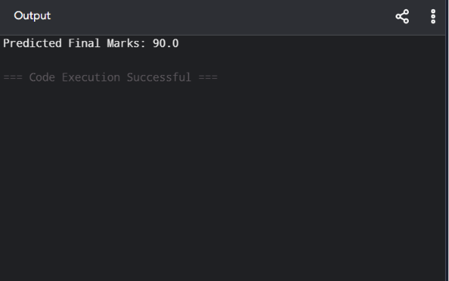

Dataset 3: Employee Salary Prediction
Target Variable: Salary (₹ Lakhs)

Experience (Years) | Education Level (Years) | Skill Score | Salary (₹ Lakhs)
1 | 15 | 60 | 3.5
2 | 15 | 65 | 4.2
3 | 16 | 70 | 5.1
4 | 16 | 75 | 6.0
5 | 17 | 80 | 7.2
6 | 17 | 82 | 8.0
7 | 18 | 85 | 9.1
8 | 18 | 88 | 10.0
9 | 18 | 90 | 11.2
10 | 19 | 94 | 12.5

PROGRAM
data = [
[1,15,60,3.5],
[2,15,65,4.2],
[3,16,70,5.1],
[4,16,75,6.0],
[5,17,80,7.2],
[6,17,82,8.0],
[7,18,85,9.1],
[8,18,88,10.0],
[9,18,90,11.2],
[10,19,94,12.5]
]

X=[r[:3] for r in data]
y=[r[3] for r in data]

mean=[sum(r[j] for r in X)/len(X) for j in range(3)]
scale=[max(r[j] for r in X)-min(r[j] for r in X) for j in range(3)]

A=[[1]+[(r[j]-mean[j])/scale[j] for j in range(3)] for r in X]

def T(A):
return list(map(list,zip(*A)))

def M(A,B):
return [[sum(A[i][k]*B[k][j] for k in range(len(B)))
for j in range(len(B[0]))] for i in range(len(A))]

def inv(A):
n=len(A)
I=[[float(i==j) for j in range(n)] for i in range(n)]

for i in range(n):
p=A[i][i]

for j in range(n):
A[i][j]/=p
I[i][j]/=p

for k in range(n):
if k!=i:
p=A[k][i]

for j in range(n):
A[k][j]-=p*A[i][j]
I[k][j]-=p*I[i][j]

return I

At=T(A)

w=M(M(inv(M(At,A)),At),[[v] for v in y])

new=[7,18,86]
new=[(new[j]-mean[j])/scale[j] for j in range(3)]

prediction=w[0][0]+sum(w[j+1][0]*new[j] for j in range(3))

print("Predicted Salary:",round(prediction,2),"Lakhs")

OUTPUT

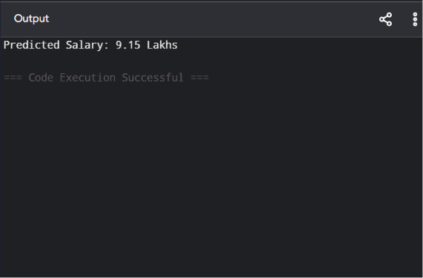

Dataset 4: Car Fuel Efficiency Prediction
Target Variable: Mileage (km/L)

Engine Capacity (L) | Vehicle Weight (kg) | Speed (km/h) | Mileage (km/L)
1.0 | 900 | 60 | 24
1.2 | 950 | 70 | 22
1.4 | 1050 | 80 | 20
1.6 | 1150 | 90 | 18
1.8 | 1250 | 100 | 16
2.0 | 1350 | 110 | 15
2.2 | 1450 | 120 | 13
2.4 | 1550 | 130 | 12
2.6 | 1650 | 140 | 11
2.8 | 1750 | 150 | 10

PROGRAM

data=[
[1.0,900,60,24],
[1.2,950,70,22],
[1.4,1050,80,20],
[1.6,1150,90,18],
[1.8,1250,100,16],
[2.0,1350,110,15],
[2.2,1450,120,13],
[2.4,1550,130,12],
[2.6,1650,140,11],
[2.8,1750,150,10]
]

X=[r[:3] for r in data]
y=[r[3] for r in data]

mean=[sum(r[j] for r in X)/len(X) for j in range(3)]
scale=[max(r[j] for r in X)-min(r[j] for r in X) for j in range(3)]

A=[[1]+[(r[j]-mean[j])/scale[j] for j in range(3)] for r in X]

def T(A):
return list(map(list,zip(*A)))

def M(A,B):
return [[sum(A[i][k]*B[k][j] for k in range(len(B)))
for j in range(len(B[0]))] for i in range(len(A))]

def inv(A):
n=len(A)
I=[[float(i==j) for j in range(n)] for i in range(n)]

for i in range(n):
p=A[i][i]

for j in range(n):
A[i][j]/=p
I[i][j]/=p

for k in range(n):
if k!=i:
p=A[k][i]

for j in range(n):
A[k][j]-=p*A[i][j]
I[k][j]-=p*I[i][j]

return I

At=T(A)
w=M(M(inv(M(At,A)),At),[[v] for v in y])

new=[1.5,1100,85]
new=[(new[j]-mean[j])/scale[j] for j in range(3)]

prediction=w[0][0]+sum(w[j+1][0]*new[j] for j in range(3))

print("Predicted Mileage:",round(prediction,2),"km/L")

OUTPUT

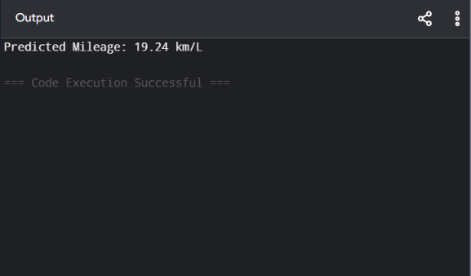

Dataset 5: Sales Prediction
Target Variable: Monthly Sales (₹ Lakhs)

Advertising Cost (₹ Thousands) | Salespersons | Store Visits | Monthly Sales (₹ Lakhs)
10 | 2 | 120 | 3.5
15 | 3 | 150 | 4.5
20 | 4 | 180 | 5.8
25 | 5 | 210 | 7.0
30 | 6 | 240 | 8.2
35 | 7 | 260 | 9.5
40 | 8 | 280 | 10.8
45 | 9 | 300 | 12.0
50 | 10 | 320 | 13.5
55 | 11 | 340 | 15.0

PROGRAM
data=[
[10,2,120,3.5],
[15,3,150,4.5],
[20,4,180,5.8],
[25,5,210,7.0],
[30,6,240,8.2],
[35,7,260,9.5],
[40,8,280,10.8],
[45,9,300,12.0],
[50,10,320,13.5],
[55,11,340,15.0]
]

X=[r[:3] for r in data]
y=[r[3] for r in data]

mean=[sum(r[j] for r in X)/len(X) for j in range(3)]
scale=[max(r[j] for r in X)-min(r[j] for r in X) for j in range(3)]

A=[[1]+[(r[j]-mean[j])/scale[j] for j in range(3)] for r in X]

def T(A):
return list(map(list,zip(*A)))

def M(A,B):
return [[sum(A[i][k]*B[k][j] for k in range(len(B)))
for j in range(len(B[0]))] for i in range(len(A))]

def inv(A):
n=len(A)
I=[[float(i==j) for j in range(n)] for i in range(n)]

for i in range(n):
p=A[i][i]

for j in range(n):
A[i][j]/=p
I[i][j]/=p

for k in range(n):
if k!=i:
p=A[k][i]

for j in range(n):
A[k][j]-=p*A[i][j]
I[k][j]-=p*I[i][j]

return I

At=T(A)
w=M(M(inv(M(At,A)),At),[[v] for v in y])

new=[38,7,270]
new=[(new[j]-mean[j])/scale[j] for j in range(3)]

prediction=w[0][0]+sum(w[j+1][0]*new[j] for j in range(3))

print("Predicted Monthly Sales:",round(prediction,2),"Lakhs")
OUTPUT
